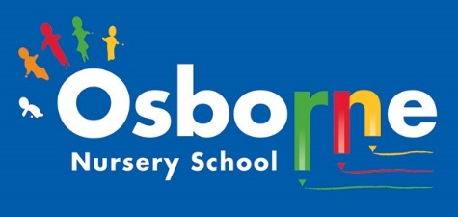
Osborne News
www. osbornenurseryschool.co.uk

May 2026
Nursery News:
We would like to welcome all the new children and their families to nursery this term! We hope that you have enjoyed making new friends and exploring our environment. Some children have moved up from Little Learners and settled quickly into life in Explorers.
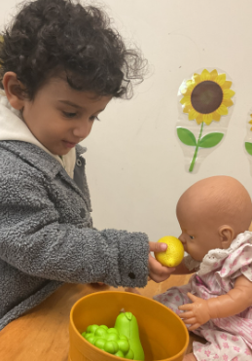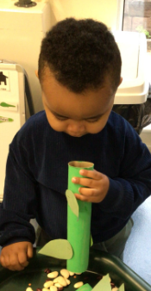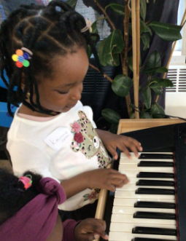
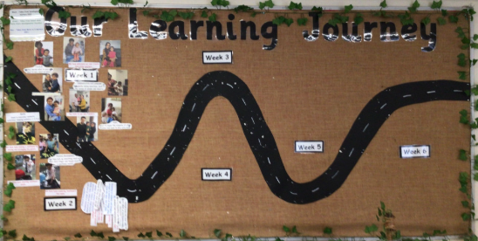
This is a photo of Little learners Learning Journey – please pop in to have a look! It is updated every week with the exciting learning opportunities the children have taken part in.

Dates for your diary:
Thursdays: Stay and Play (under 2s) every Thursday morning – 9:45 – 11:15am at OSBORNE NURSERY SCHOOL.
Monday 27th April – The Hatching experience – Caterpillars and duck eggs
Monday May 4th – NURSERY CLOSED
Wednesday 13th May – Group photographs with Academy.
Monday 25th May – Friday 29th May – HALF TERM
Friday 12th June – Little Learners Park Trip
Wednesday 24th June – Explorers trip to the park in Lichfield. Details to follow on Tapestry
WC 29th June – Parent/ carer meetings
Wednesday 8th July – Osborne Nursery School 50 Years celebration!
Please remember to telephone us on 0121 675 1123 if your child is too ill to be at nursery.

Attendance is very important at Nursery. We like to see you for all your sessions each week. Families should aim for attendance to be between 95 and 100%. Look out for the Cool Kittens stickers! Congratulations to Squares AM and Caterpillars PM for the best attendance in Nursery in April 2026. FANTASTIC!! Well done to the parents and carers too.

The hatching experience: We have had 5 eggs delivered and they are currently sitting in the incubator, and we are waiting for them to hatch. Little Learners have caterpillars, and they are just beginning to change into a cocoon. It is very exciting.

There will be updates on Tapestry!




It has been confirmed that we are now a BRONZE Rights Respecting School!
Silver is the next challenge! Liz has been busy preparing all our evidence to share with the assessors so we can achieve silver very soon!
Ronnie Rabbit is helping the children understand their rights.

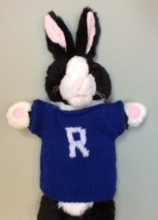
What do you do at home to relax and play? We would love to see some photographs of activities that you do.

Rights Respecting Schools Award (RRSA)
Internet safety: SCAMS
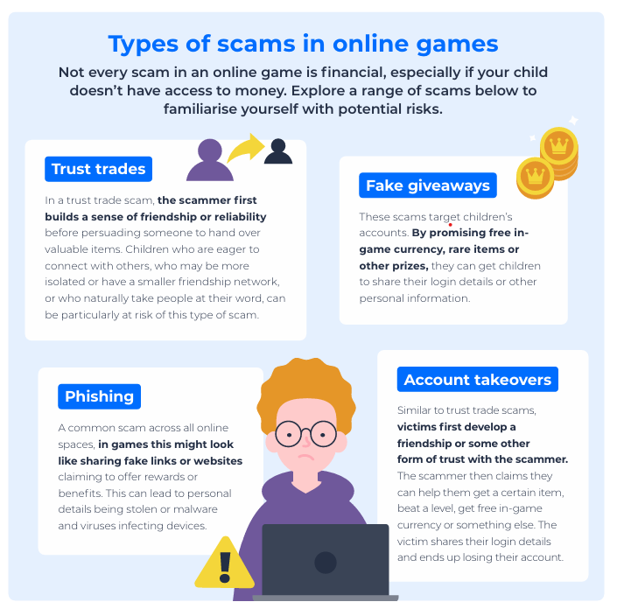

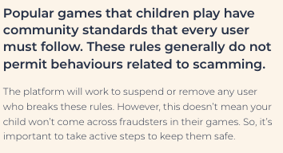
Teach your child to talk to you about their internet use, don’t leave your child alone on line. Ensure that you have applied parental controls and you have rules around screen time and acceptable websites and apps.

This month’s recommended reads are:

We are reading these books in nursery. The Very Hungry Caterpillar is being shared with Little Learners – they have their very own caterpillars in class! They are watching them grow and change.
Oh Dear links to our projects all about life cycles and changes.

School Places: If your child is due to start school in September, you should have received the name of the school. It is an exciting time. At nursery we have already stated to talk about school and prepare the children for this change. We will be contacting the local primary schools, hosting visits and attending transition events to share information with schools. We hope that this will help your child to settle into school life quickly.
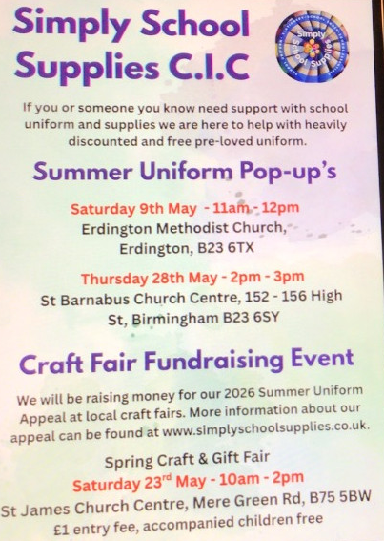
As the weather gets warmer (hopefully!) don’t forget to apply sun cream before arriving at nursery. You can also send a sun hat to, this help to protect their head as they play outside.

